Name: udaya byreddy

Student id: 16293204

Assignment 4- creating 2 API’s using Ionic

Class id: 3

Lab id: 6_2

Partner name: Madhuri sarda

Below are the screen shots of login, register, google search API and Twitter search API

1.login page

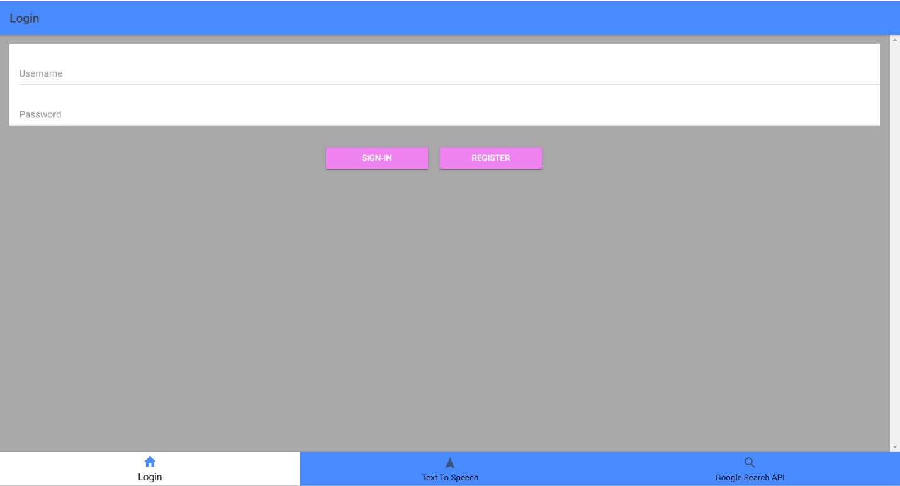

2.Registration page for a new user on click of registration

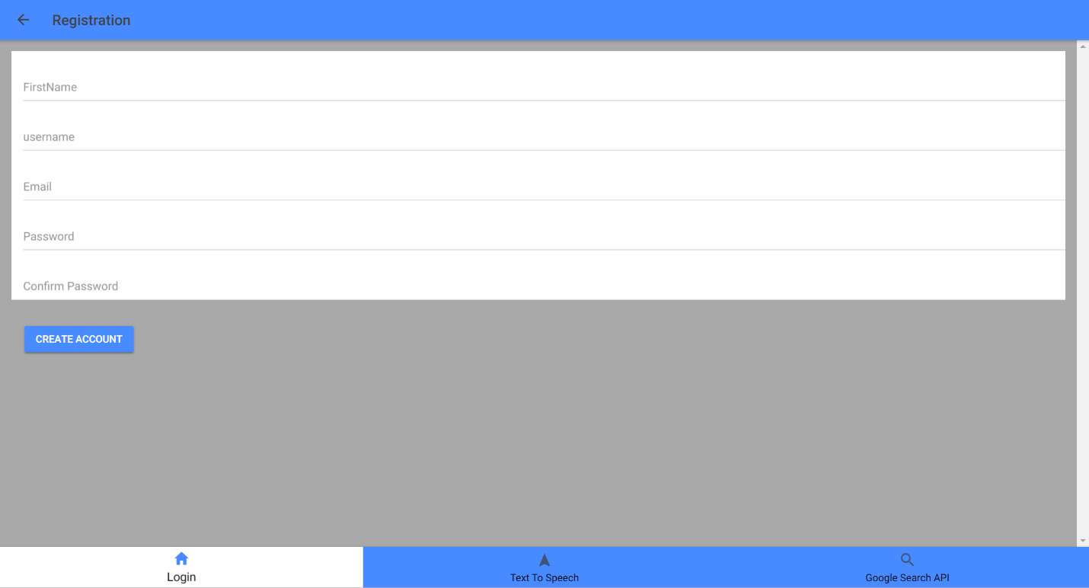

3.Registration page

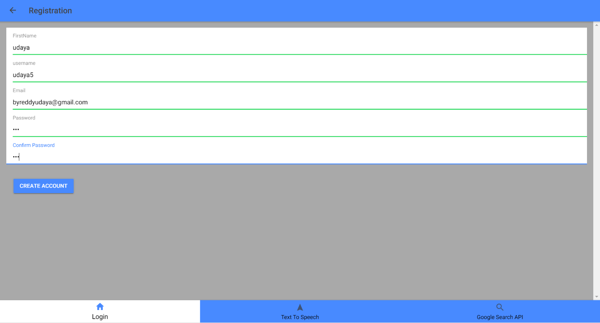

4.Google search API on click

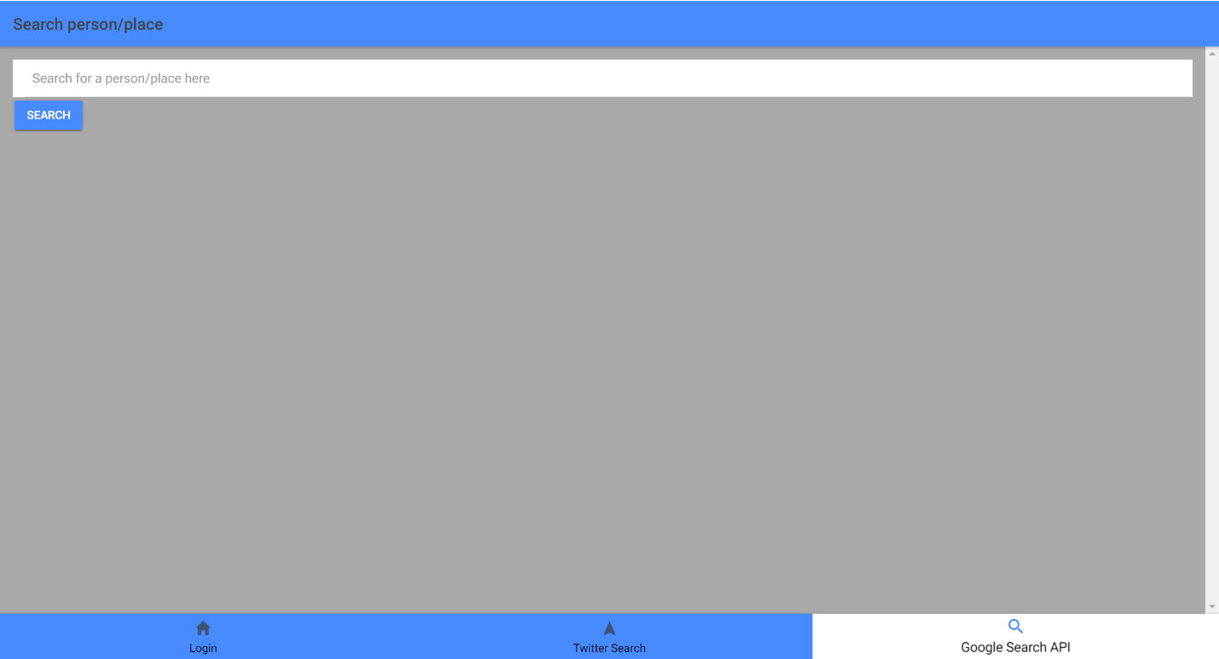

5.Google search API page after search

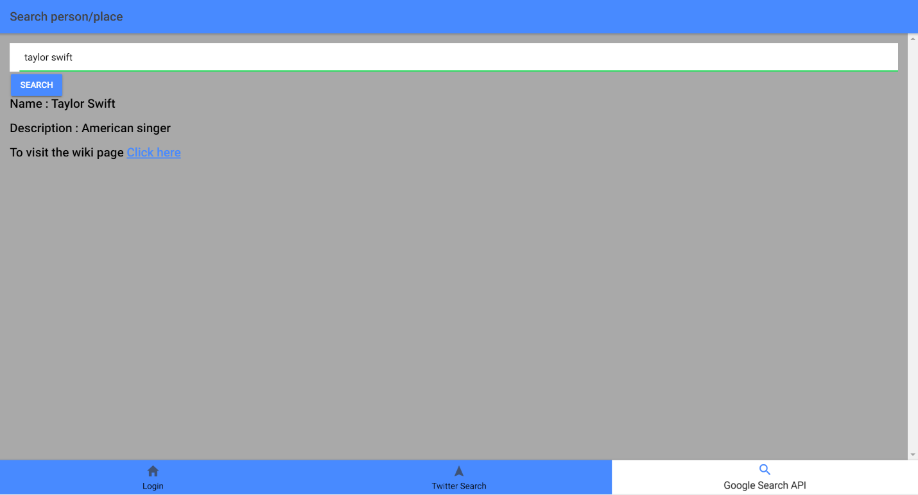

6.Twitter search API on click

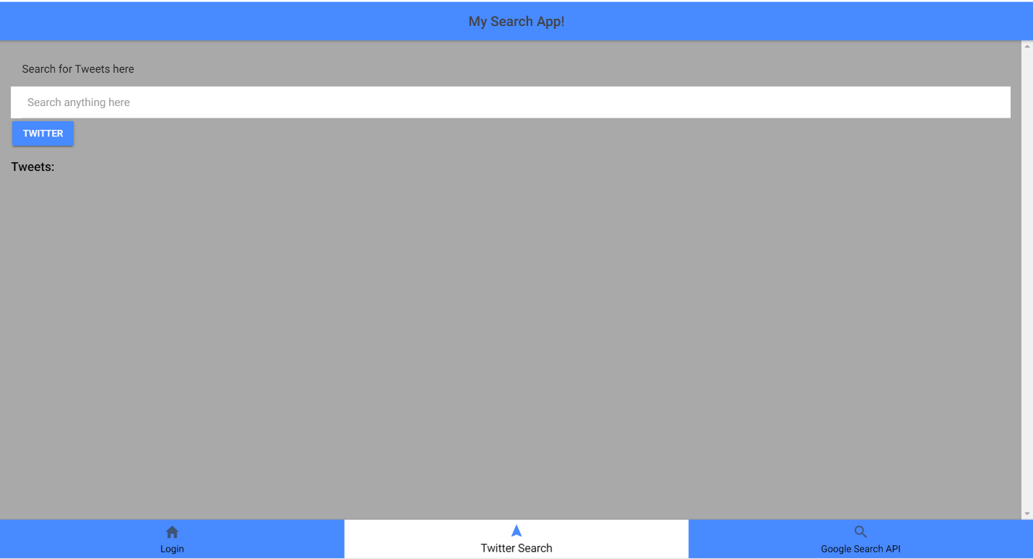

7.Twitter search API after search

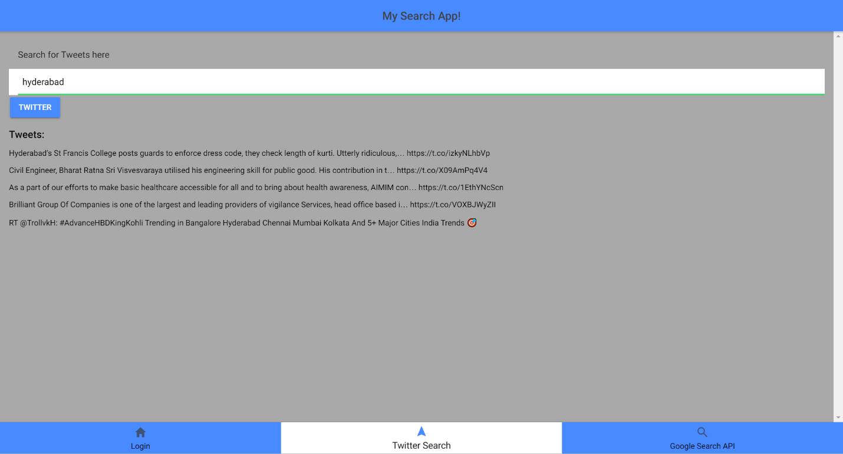

8.After login page is redirected to Google search API

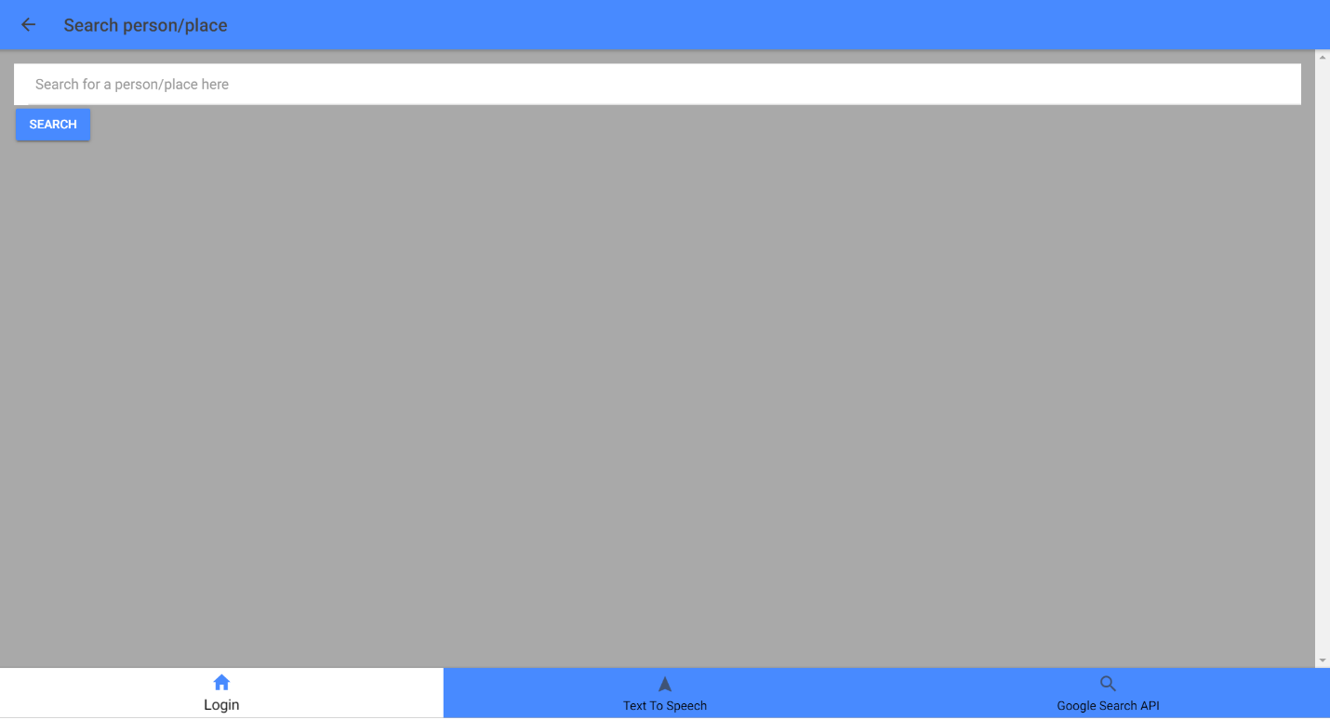

9.local storage after user registering

